Contents

Abstract ……………………………………………………………… 2

Design ……………………………………………………………… 3

Website wide features…………………………………………………… 3

Home page features….…………………………………………………… 4

Portfolio page features…………………………………………………… 4

Brands page features……………………………………………………… 5

Projects page features …………………………………………………… 5

Contact page features………….………………………………………… 6

About page features………….…………………………………………… 6

Wireframe …………………………………………………………… 7

Conclusion …………………………………………………………… 7

Abstract

This website was created with the purpose of being a portfolio / business website for graphic designer Jonathan Kelly. Jonathan wished to show his portfolio and brand work along with other projects he has worked on. The website needed to match the field Jonathan works in and show case the work in a clean, easy to navigate fashion. Jonathan is based in London and wished to have a contact section with embedded Google map marking his location with a small information box.

Design

The design of the website needed to compliment the content the website was created for. Graphic Design websites are normally minimal on text, showing of the images with little distraction. The website was designed to have continuity across each page. The idea behind continuity for the design is to make the website easily accessible to navigate. Users should find it easy to locate their current section and any section they wish to visit. The design features of the website are documented below.

Website wide features

* Identical width of content area
* Identical width of navigation bar
* Identical width of footer
* Color used to highlight current page
* Identical font size within the body
* Identical distance from Navigation bar to content
* Identical distance from end of content to footer
* Identical Background image

After creating a website that was easy to navigate the next step in the design process was to showcase Jonathan Kelly’s work. Every image external of the portfolio and brands page is clickable. Clicking on an image either links the user to the project that image comes from or enlarges the image on the current page.

Home page features

* Brief welcome and introduction
* Accessibility features (enlarge text)
* Rotating 3 image slideshow (clickable w/ tooltip)
* Professional table (clickable images, links, alternate data design)

The index sets the tone for the entire website, with clean well spaced out images and text. Accessibility features to allow the user to enlarge the text. The table at the bottom of the page displays an image with the information relative to the image contained in the box below. Each alternate box has a complimenting style to allow ease of focus on one area. The content within the table data is padded to make reading easier.

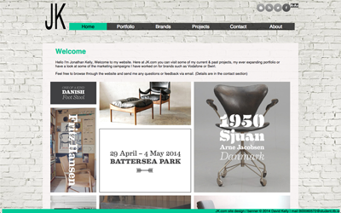 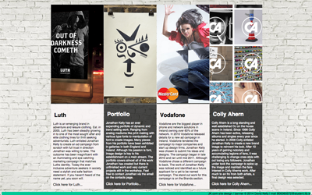

Portfolio page features

* Use of JSON to access information of clicked project
* Accessibility features (enlarge text)
* Rotating 7 image slideshow

Following the theme of a clean website with focus on images. The portfolio page makes advantage of JQuery. Loading JSON files in to a content area to read about the selected project. The only visible item on the page before clicking a project is the rotating slideshow highlighting the images contained within the clickable projects.

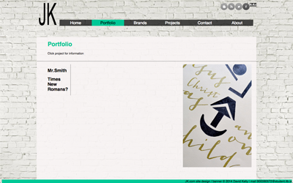 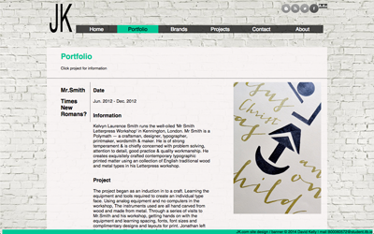

Brands page features

* Accordion widget

The brands page is the most purest page on the website, containing no text and simply imagery. Like most graphic design websites the images are separate from the information to allow the user to focus solely on the graphic with out distraction from text. The information about each project is on a separate project page. When the user selects a project the accordion widget is activated and drops down to reveal the images contained within. The images are displayed in two widths 420px and 860px.

Upon clicking a second project title, the first project closes and disappears leaving the latest project the only one viewable on the page.

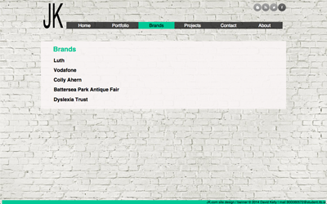 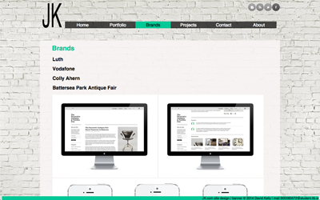

Projects page features

* Professional style table (alternate row and hover color)
* Style switcher

The project page contains all the detailed information about each project. The details are contained within a professional style table. Each alternate row is styled with a different background color to allow ease of reading for the user. At the bottom of the page is a drop box style-switcher that allows the user to change the dominant theme color of the page.

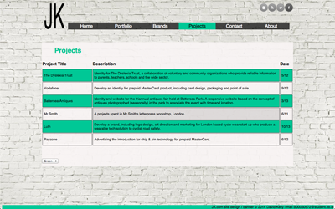 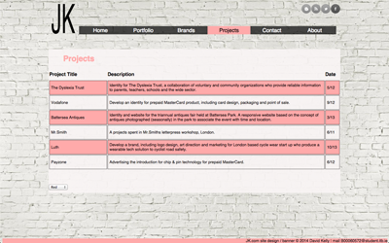

Contact page features

* Selectable Image
* Working email
* Google map (marker, information box & directions)

The contact page has the details to allow a user to contact Jonathan Kelly, via phone, email or his business location. A functioning Google map is embedded on the page with a clickable location marker containing information for Jonathan Kelly. Users are able to select a starting location to get directions. Otherwise the user can enter their location in the text box provided and get an external directions link. Users can also use the clickable email link provided to send an email. Below the contact information is an image that when clicked, enlarges to show the entire image fixed in the center of the screen. Clicking on this large image will close it, Thus reducing buttons and accommodating intuitive interaction.

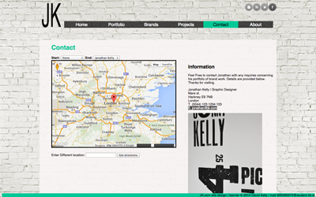 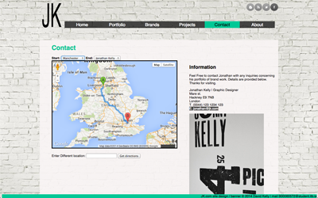

About page features

* Accordion widget
* Resizable text area

The about page contains a site map for the website. Contained within an accordion widget that does not retract automatically, allowing users to view the entire website in one view. In the center of the page is a text area where a user can enter text and click a send button to submit their text.

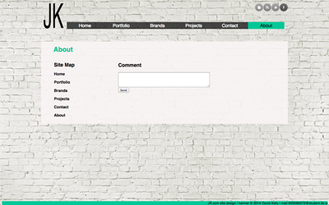 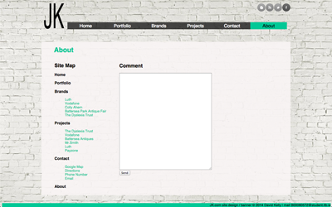

Wireframe

The Original Designs for the website were drafted out in wireframe. With estimates for website, width and height for each page. Content was then added to the mock up to give a rough idea of layout design. The original wireframe images can be seen below.

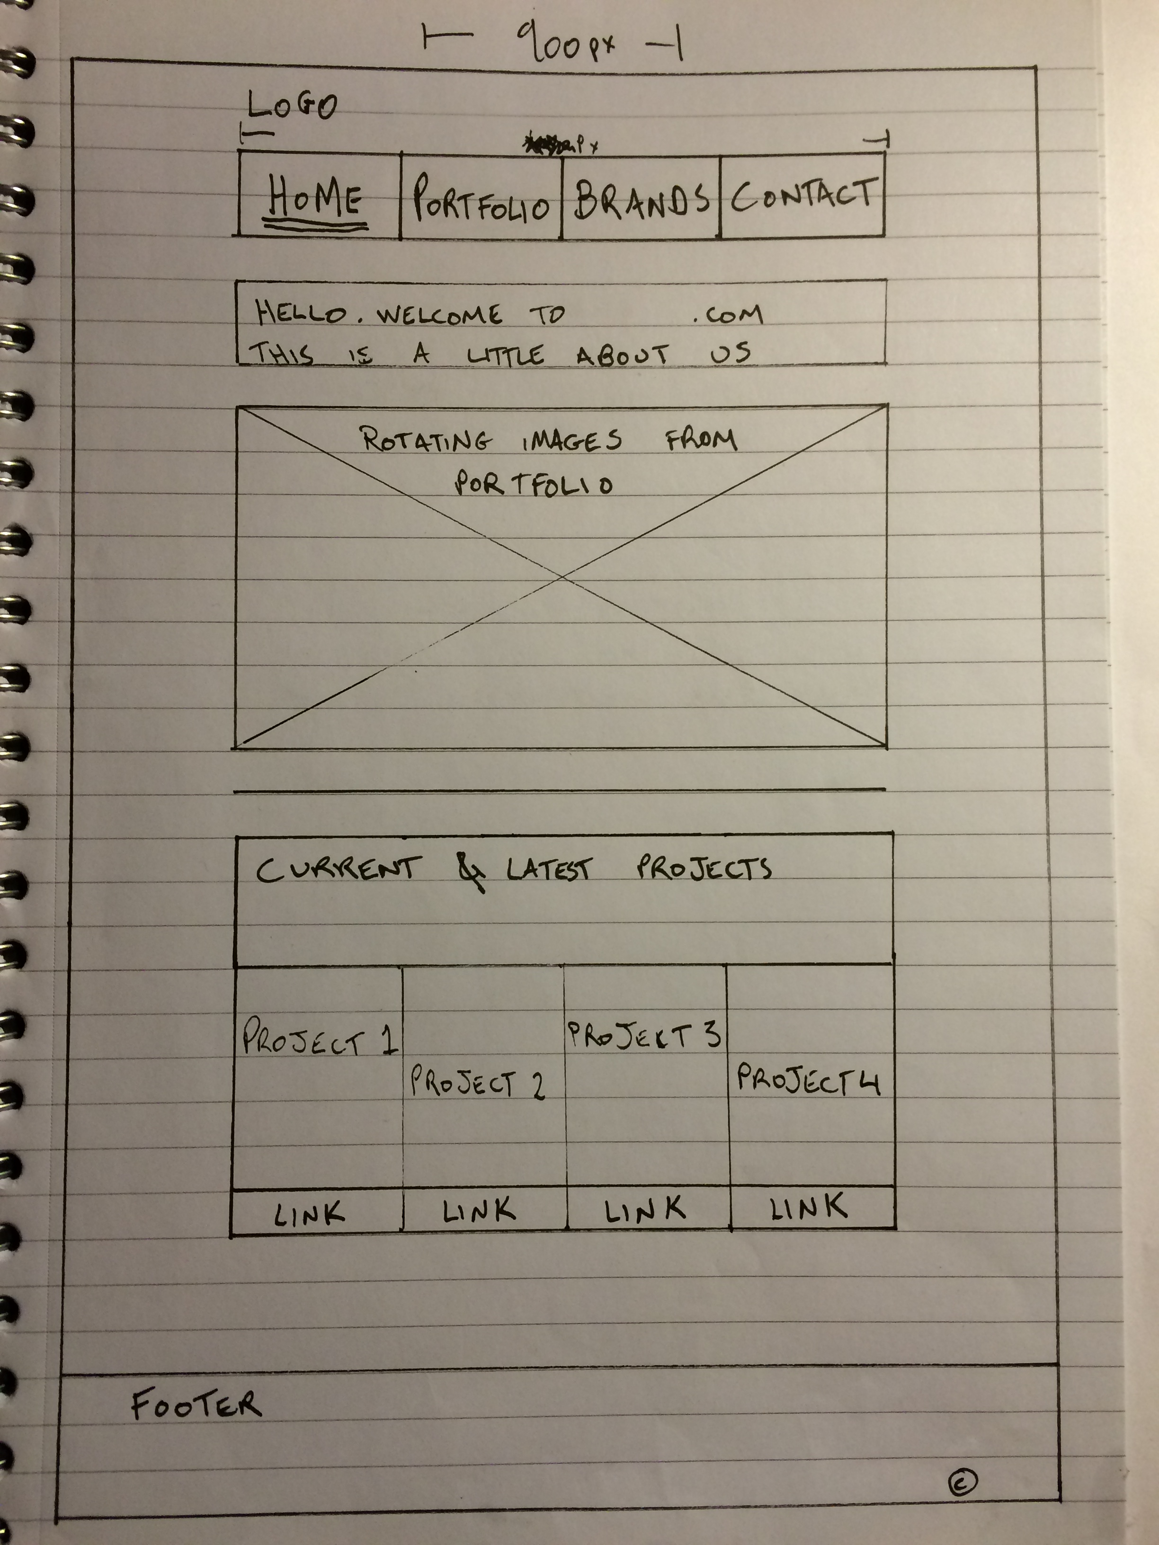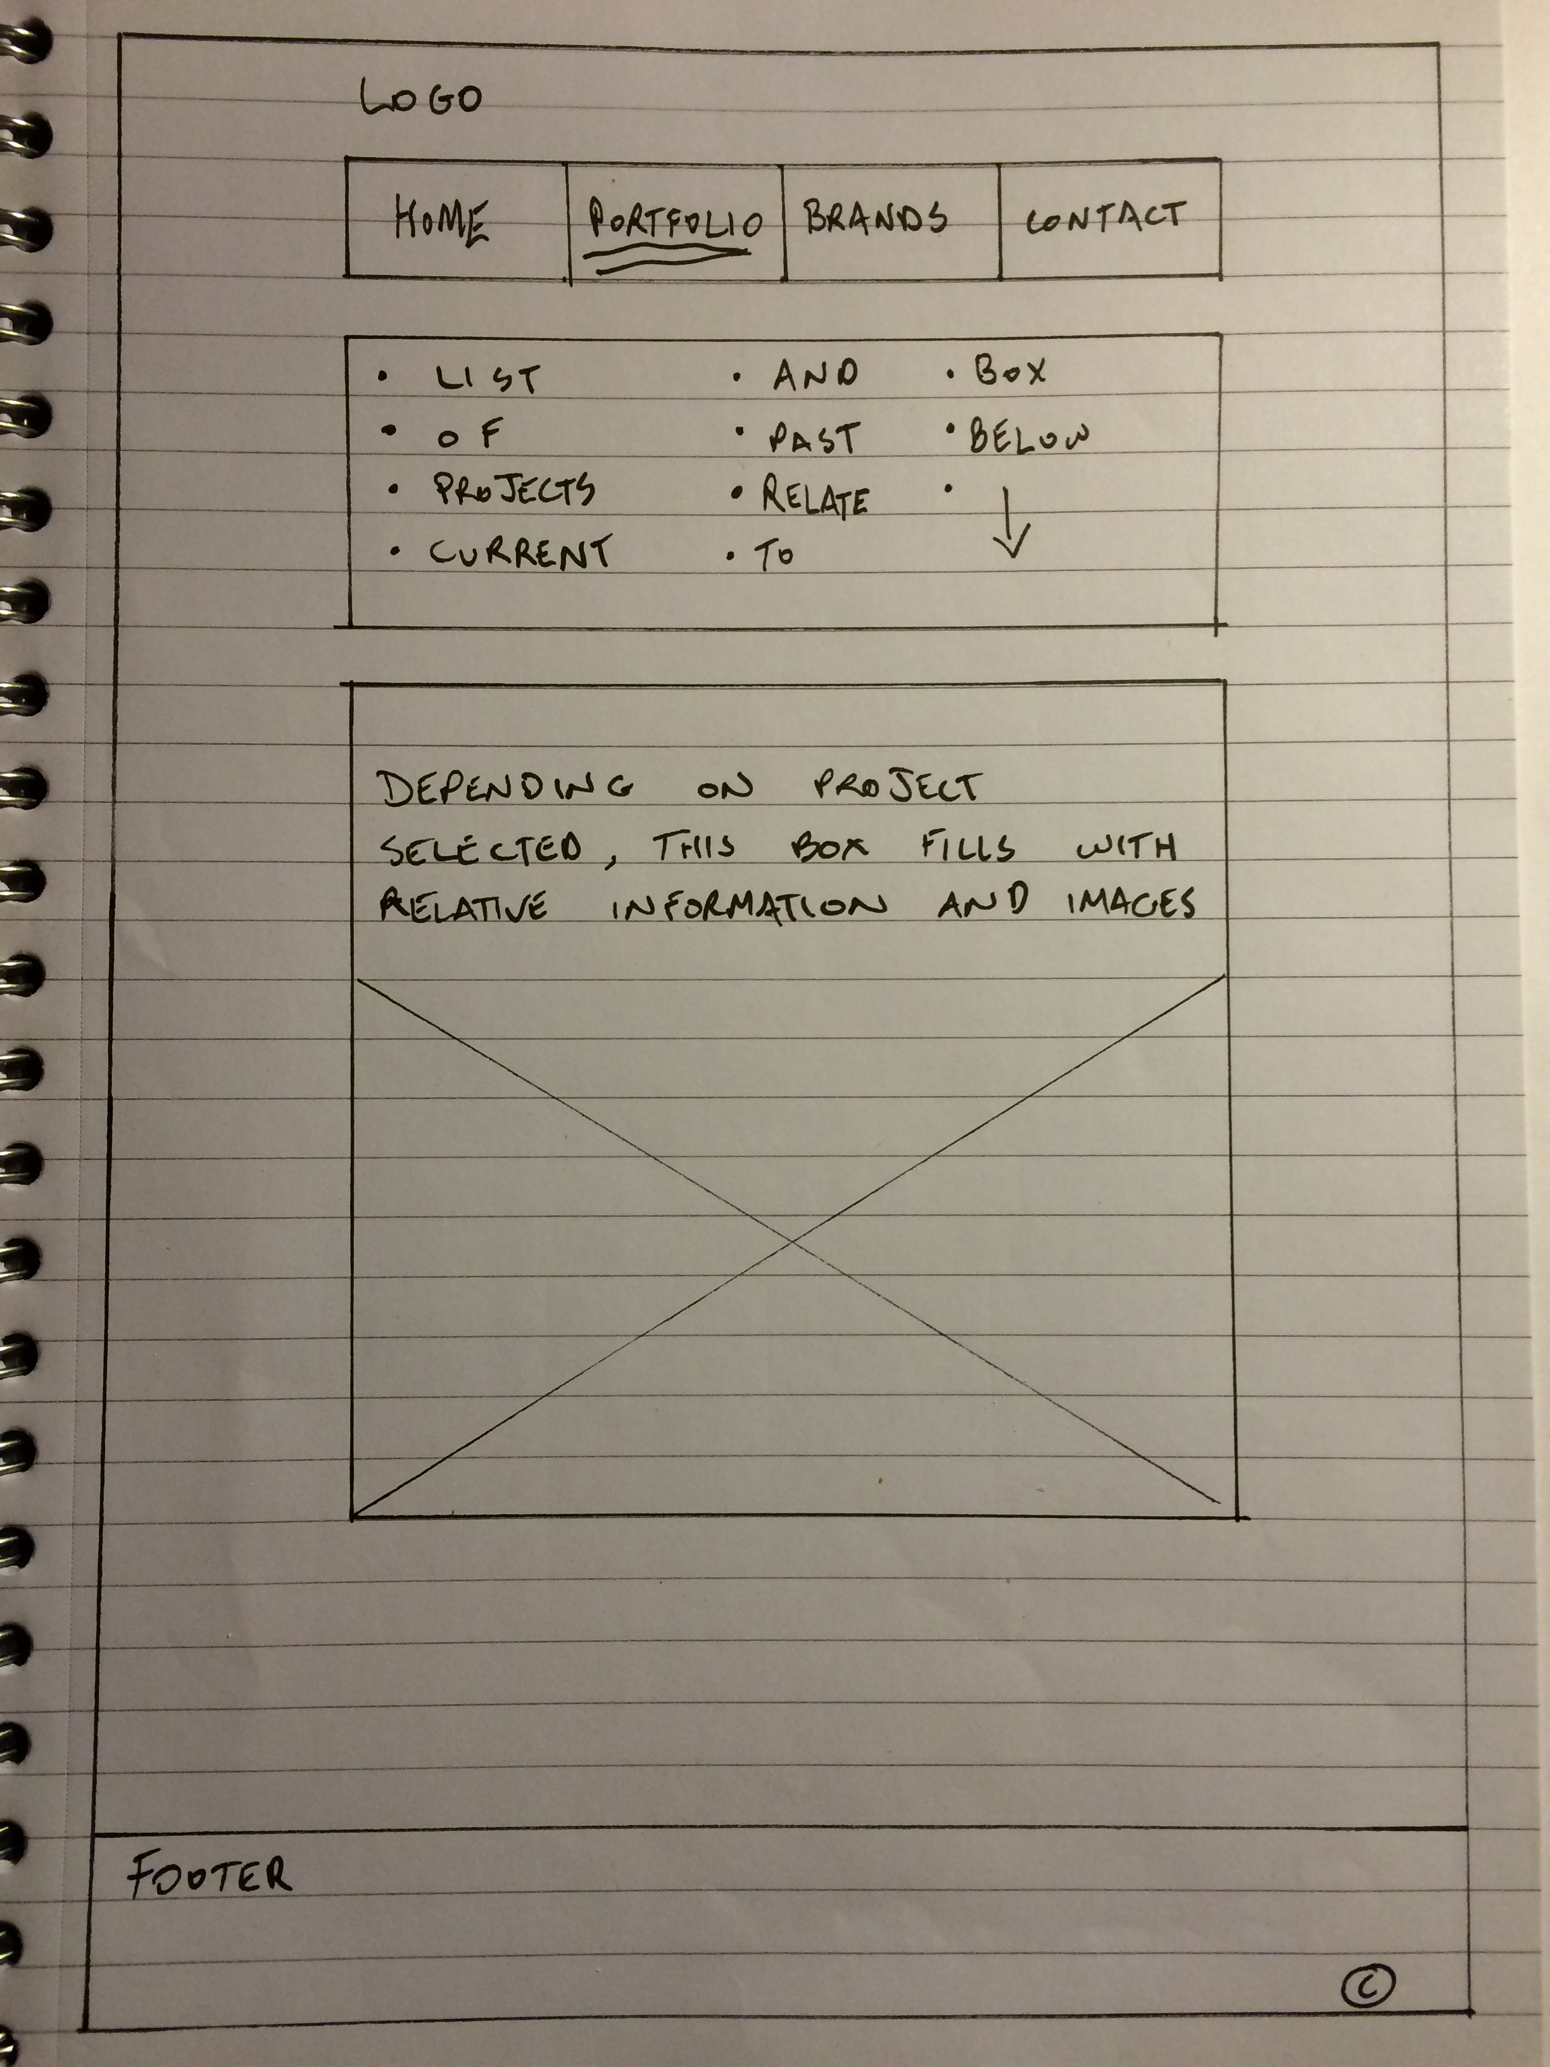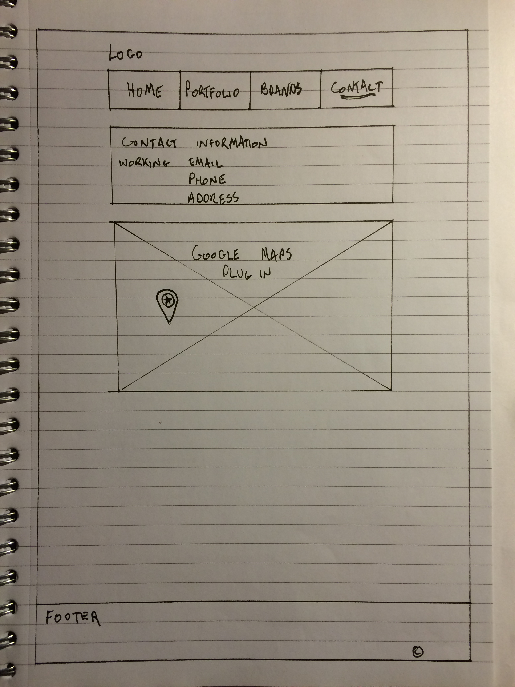

Conclusion

During the creation of this website I learned a lot of new methods for web design and website construction. This is the first time I ever implemented a wireframe technique for layout of the web page content. Many pages of my website implement JQuery for an interactive feel, up until now I have never used any sort of technique that responds to the user within the webpage. Using JQuery to create, slideshows, accessibility features, JSON, AJAX and XML, widgets and style switchers. This is the first project I have used an embedded Google map with a marker and direction services. I found Google maps challenging at first but after getting the simplest form of Google maps working, it was only a case of expanding on the code within. I found this project challenging to implement all the required items however I think my website functions and looks very well upon completion of the tasks.